

Work Health and Safety Templates for Group Leaders

This document includes a series of templates to enable Groups to address a range of common work health and safety compliance areas.

## Table of Contents

Scouts SA Hall Self -Assessment 2

Emergency Contacts 7

Emergency Procedures 8

Emergency Response Observers’ Checklist 12

Emergency Management Toolbox Talk 13

First Aid Kit Location Sign 14

Qualified First Aiders 15

Register of First Aid Kits 16

National Workplace First Aid Kit - Softbag Portable Xlarge 17

Deluxe Personal First Aid Kit Content 18

Work Health & Safety Vehicle First Aid Kit Content 19

Register of Fire Equipment 20

Trailer 6 monthly Inspection - Basic Checklist 21

Cleaning Roster 22

# Scouts SA Hall Self -Assessment

|  |  |
| --- | --- |
| **Question** | **Response** |
| Fire and Emergency | |
| 1.1 Are all access and exit points readily accessible (clear and no locks restricting them)? | Safe/At Risk/NA |
| Action: | |
| 1.2 In halls where sleep overs occur, are push bar door handles fitted? | Safe/At Risk/NA |
| Action: | |
| 1.3 Are emergency exit points clearly marked and in the location shown in the evacuation diagram for the site? | Safe/At Risk/NA |
| Action: | |
| 1.4 Are emergency procedures readily accessible? | Safe/At Risk/NA |
| Action: | |
| 1.5 Fire extinguishers are accessible and in designated locations? | Safe/At Risk/NA |
| Action: | |
| 1.6 Are illuminated exit signs installed over exits? | Safe/At Risk/NA |
| Action: | |
| 1.7 Have emergency exit lights been serviced and inspected in the last 6 months? | Safe/At Risk/NA |
| Action: | |
| 1.8 Have fire extinguishers been tested in the last 6 months? | Safe/At Risk/NA |
| Action: | |
| 1.9 Have fire extinguishers been discharged and recharged in the last 6 years? | Safe/At Risk/NA |
| Action: | |
| 1.10 Is a fire blanket mounted on the wall in the kitchen? | Safe/At Risk/NA |
| Action: | |

|  |  |
| --- | --- |
| 1.12 Are smoke detectors in place and serviceable | Safe/At Risk/NA |
| Action: | |
| 1.13 Have potential emergency situations been identified and response protocols documented? | Safe/At Risk/NA |
| Action: | |
| 1.14 Are people on site aware of the emergency procedures? | Safe/At Risk/NA |
| Action: | |
| 1.15 Emergency contact numbers are clearly displayed at appropriate locations? | Safe/At Risk/NA |
| Action: | |
| 1.16 Has an emergency evacuation plan been tested in the last 12 months? | Safe/At Risk/NA |
| Action: | |
| 1.17 Are the names of qualified First Aiders clearly displayed at suitable locations around the site? | Safe/At Risk/NA |
| Action: | |
| 1.18 Do leaders know how to report an incident? | Safe/At Risk/NA |
| Action: | |
| 1.19 Is the First Aid kit location accessible and clearly identified? | Safe/At Risk/NA |
| Action: | |
| 1.20 Does each First Aid Kit have a contents list? | Safe/At Risk/NA |
| Action: | |
| 1.21 Is the First Aid kit content consistent with the contents list (if available)? | Safe/At Risk/NA |
| Action: | |
| 1.22 Is the First Aid Kit content within expiry dates? | Safe/At Risk/NA |
| Action: | |

### 

|  |  |
| --- | --- |
| Housekeeping | |
| 2.1 Are activity areas tidy, organised and free of clutter? | Safe/At Risk/NA |
| Action: | |
| 2.2 Are walkways uncluttered and free of obstruction? | Safe/At Risk/NA |
| Action: | |
| 2.3 Are external footpaths and activity areas free of trip hazards, clutter or damage? | Safe/At Risk/NA |
| Action: | |
| 2.4 Are internal floor surfaces, including stairs, clean and in good condition? | Safe/At Risk/NA |
| Action: | |
| 2.5 Are all handrails in good condition? | Safe/At Risk/NA |
| Action: | |
| 2.6 Are drawers and filing cabinets closed when not in use? | Safe/At Risk/NA |
| Action: | |
| 2.7 Are changes in heights in walkways clearly identified? | Safe/At Risk/NA |
| Action: | |
| 2.8 Is the activity area free of unsecured sharp edges or surfaces that could cause injury during the course of activities? | Safe/At Risk/NA |
| Action: | |
| 2.9 Is the space available in office areas being used in a way that provides for safe storage? | Safe/At Risk/NA |
| Action: | |
| Storage | |
| 3.1 Are racks and shelves in good condition and suited to purpose? | Safe/At Risk/NA |
| Action: | |
| 3.2 Are items stored securely so that they are not at risk of falling? | Safe/At Risk/NA |
| Action: | |
| 3.3 Are chemicals labelled and safely stored? | Safe/At Risk/NA |
| Action: | |
| 3.4 Are all items stored safely so they are secure and not at risk of falling? | Safe/At Risk/NA |
| Action: | |
| 3.5 Are frequently used items stored between knee and shoulder height? | Safe/At Risk/NA |
| Action: | |
| 3.6 Are gas bottles stored in an upright position and able to vent outside the building? | Safe/At Risk/NA |
| Action: | |
| Electrical | |
| 4.1 Are current test tags attached to all portable electrical items? 5 years fixed, 12 months portable. | Safe/At Risk/NA |
| Action: | |
| 4.2 Have all double adapters and piggy back plugs been removed? | Safe/At Risk/NA |
| Action: | |
| 4.3 Is the use of extension cords limited to temporary use only? | Safe/At Risk/NA |
| Action: | |
| 4.4 Is electrical equipment operated in a safe environment? | Safe/At Risk/NA |
| Action: | |
| Facilities | |
| 5.1 Are toilet areas clean and stocked? | Safe/At Risk/NA |
| Action: | |
| 5.2 Are soap, running water and sanitary hand drying facilities available? | Safe/At Risk/NA |
| Action: | |
| 5.3 Are kitchen areas kept clean (including the refrigerator)? | Safe/At Risk/NA |
| Action: | |
| 5.4 Is food regularly checked for best by dates or use by dates? | Safe/At Risk/NA |
| Action: | |
| 5.5 Where showers are in place, are they fit for use? | Safe/At Risk/NA |
| Action: | |
| 5.6 Termite Inspections conducted in last 12 months? | Safe/At Risk/NA |
| Action: | |
| 5.7 Evaporative Air Conditioner serviced in last 12 months? | Safe/At Risk/NA |
| Action: | |
| 5.8 Fires/Heaters guards in place? | Safe/At Risk/NA |
| Action: | |
| Asbestos | |
| 6.1 Does the building have a current asbestos register? | Safe/At Risk/NA |
| Action: | |
| 6.2 Is the asbestos management plan up to date and readily accessible? | Safe/At Risk/NA |
| Action: | |
| 6.3 Are asbestos containing materials on site clearly identified? | Safe/At Risk/NA |
| Action: | |
| Incident Management | |
| 7.1 Injuries and incidents are recorded | Safe/At Risk/NA |
| Action: | |
| 7.2 The incident reporting process is displayed and understood. | Safe/At Risk/NA |
| Action: | |

|  |  |  |  |
| --- | --- | --- | --- |
| **Actions to be taken** | | | |
| Item No. | Action | Person Responsible | Target Date |
|  |  |  |  |
|  |  |  |  |
|  |  |  |  |
|  |  |  |  |
|  |  |  |  |
|  |  |  |  |
|  |  |  |  |
|  |  |  |  |
|  |  |  |  |
|  |  |  |  |
|  |  |  |  |
|  |  |  |  |

Date Last Reviewed

Date Last Reviewed

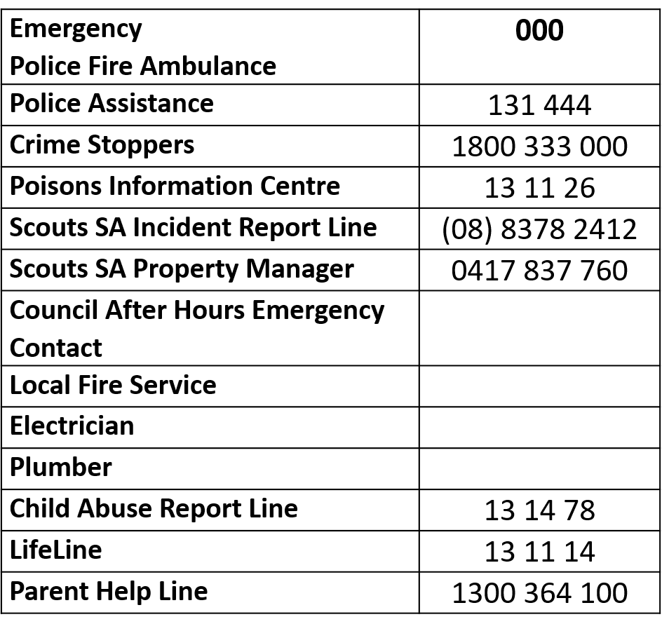

# Emergency Contacts

# Emergency Procedures

## Lock Down, Evacuation, Earthquake

## Lock Down

A Lock Down may be called when there is a hazard near a Scout Hall, or building where a Scouting activity is conducted that requires members, parents and visitors to be locked in a building for their own safety.

In general, terms a Lock Down would be initiated when the threat is external to the building. Situations that trigger a Lock Down may include:

* Bad Weather
* Toxic Spills
* Civil Unrest
* Dangerous Persons
* Direction by Authorities

## Initiating a Lock Down

A Lock Down is initiated by the Leader-In-Charge.

The Lock Down alert will be given by (Enter your protocol here) (e.g. Five whistle blasts, continuous ringing of the Ship’s Bell, “Pack, Pack, Pack” *pause* “Pack, Pack, Pack” *repeated)*

On hearing the alert all adults and children are to remain in or proceed into the hall *(or building where the Scouting activity is conducted)* immediately.

## Locking Down the Building

1. Lock all doors and windows in the building.
2. Close blinds and curtains.
3. Keep everyone inside.
4. Collect attendance list and any emergency medication (Asthma Medication, Epi Pen).
5. Move everyone to the Safe Room (Identify the Safe Room Here) and lock or barricade the door.
6. Position people in the most non-visible positions, seated.
7. Put all mobile phones in ‘Silent’ mode and turn off vibrate function.
8. Take a roll call.
9. Remind everyone to remain quiet and seated in the Safe Room until the all clear is announced.
10. Leader-In-Charge to advise, or remain in contact with, Police or Emergency Services (000) as appropriate.
11. No other phone calls are to be made.
12. When Police or Emergency Services announce the all clear, leave the Evacuation Assembly Point in an orderly manner.
13. Advise parents after a Lock Down has occurred.
14. Complete an Incident Report.

***The Safe Room is a room that has few or no windows and a lockable door.***

***If the door cannot be locked, it should be barricaded from the inside****.*

**Emergency Evacuation**

An Emergency Evacuation may be called when there is a hazard inside a Scout Hall, or building where a Scouting activity is conducted that requires members, parents and visitors to be vacate a building for their own safety.

In general, an Evacuation would be initiated when the threat is inside the building. Situations that trigger an Emergency Evacuation may include:

* Fire
* Wildlife in the building (Snakes)
* Uncontrollable and dangerous behaviour
* Direction by Authorities

## Site Evacuation Diagram

A Site Evacuation Diagram should be located immediately adjacent to each exit door. It shall clearly identify the current location in the hall, the nearest emergency exit, and the path to follow to the Evacuation Assembly Point located at (Identify the Evacuation Assembly Point here).

## Initiating an Emergency Evacuation Lock Down

An Emergency Evacuation is initiated by sounding the Evacuation Alert.

The Emergency Evacuation alert will be given by (Enter your protocol here)

(E.g. Three whistle blasts, continuous ringing of the Ship’s Bell, smoke alarm alert “Evacuate Now” *repeated)*

## Evacuating the Building

1. On hearing the alert all adults and children are to leave the hall in accordance with the Site Evacuation Diagram immediately.
2. Leader-In-Charge to contact with Police or Emergency Services (000) as appropriate.
3. A Leader shall collect the attendance list and any emergency medication (Asthma Medication, Epi Pen).
4. Leaders and Adults shall assist and guide children to the Evacuation Assembly Point.
5. Leaders and Adults shall encourage people to remain calm and move quickly.
6. Take a roll call when assembled at the Evacuation Assembly Point.
7. Remind everyone to remain quiet and calm at the Evacuation Assembly Point until the all clear is announced.
8. No other phone calls or social media announcements are to be made.
9. When Police or Emergency Services announce the all clear, leave the Evacuation Assembly Point in an orderly manner.
10. Parents must be advised after an Emergency Evacuation has occurred.
11. Complete an Incident Report.

**Earthquake**

1. Adults shall endeavour to stay calm and reassure children.
2. Stay indoors.
3. When an earthquake is initially felt, the Leader-In-Charge shall direct everyone to:
   1. Drop down to the floor.
   2. Keep away from:
      1. Windows
      2. Book cabinets
      3. Filing cabinets
      4. Heavy hanging objects
      5. Anything hanging from the ceiling (kayaks, pioneer poles, ladders)
   3. Take cover:
      1. Under a table
      2. Under a door frame
      3. Against an internal wall
   4. Protect head and neck with their arms.
   5. Keep in this position until the building stops shaking and advised it is safe to move.
   6. If an evacuation is required, follow the Emergency Evacuation protocols.
      1. Check for:
         1. Clear paths of travel.
         2. Fallen power lines, gas leaks, unstable structures.
      2. If safe to do so, take first aid kit.
   7. Move to Evacuation Assembly Area (Identify the Evacuation Assembly Point here).only if safe to do so.
   8. If not safe to do so, find an alternate point nearby.
4. Reassure each other.
5. Remain at the Evacuation Assembly Area.
6. Wait for direction from Police or Emergency Services.
7. Parents must be advised after an Emergency Evacuation has occurred.

|  |  |  |  |  |
| --- | --- | --- | --- | --- |
| Emergency Response Observers’ Checklist | | | | |
| Date | | Time | | |
| Type of Emergency |  | | | |
| Location/Group |  | | | |
| **Emergency Response Sequence** | | | **Time** | |
| **Hours** | **Minutes** |
| Alarm/Warning Sounded | | |  |  |
| Leaders Respond | | |  |  |
| All areas checked | | |  |  |
| Leaders report areas of responsibility clear | | |  |  |
| Persons with disability accounted for | | |  |  |
| Arrive at assembly area/safe place | | |  |  |
| Leaders check everyone is present | | |  |  |
| Evacuation completed | | |  |  |
| Exercise Terminated | | |  |  |
| **Comments and Opportunities for Improvement** | | | | |
| Observer |  | | | |
| Signed |  | | | |

# Emergency Management Toolbox Talk

## Session Outcomes

At the end of this session you should:

* have an understanding of the strengths and weaknesses of your Group’s emergency preparedness; and
* be able to identify your Group’s existing emergency management resources

## What is an emergency?

A quick Google search will find the definition of an Emergency as:

“a serious, unexpected, and often dangerous situation requiring immediate action.”

The keywords in this statement are underlined.

What will be your immediate response to an unexpected, serious event that could cause serious harm to people?

## How prepared is your Group for an emergency?

Ask the participants the following questions and give time to answer and discuss them

* From where you are sitting, can you point out the Group’s Emergency Procedures?
* What emergencies do your Emergency Procedures cover?
* From where you are sitting, can you see a fire extinguisher?
* How quickly can you locate the contact number for the Poisons Information Centre?
* I am new to your hall. How quickly can I locate your first aid kit?
* There is a group of people fighting outside your hall during an activity night. What will you in the next 30 seconds?

## Review

* Is your Group prepared for serious and unexpected events?
* Can your Group (confidently) respond immediately?
* List your strengths and weaknesses.
* What further work is needed?

# Image result for first aid signFirst Aid Kit Location Sign

|  |  |
| --- | --- |
| Qualified First Aiders | |
| Name | Next Training Due |
|  |  |
|  |  |
|  |  |
|  |  |
|  |  |
|  |  |
|  |  |
|  |  |
|  |  |
|  |  |
|  |  |
|  |  |
|  |  |
|  |  |
|  |  |
|  |  |
|  |  |

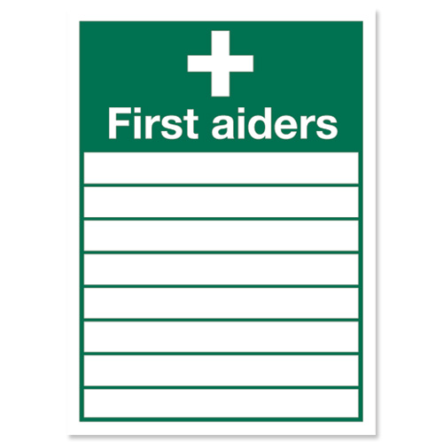

|  |  |  |  |  |
| --- | --- | --- | --- | --- |
| Register of First Aid Kits | | | | |
| **Type of Kit** | **Specific Location** | **Checked by** | **Last Checked Date** | **Next Check Date** |
|  |  |  |  |  |
|  |  |  |  |  |
|  |  |  |  |  |
|  |  |  |  |  |
|  |  |  |  |  |
|  |  |  |  |  |
|  |  |  |  |  |
|  |  |  |  |  |
|  |  |  |  |  |
|  |  |  |  |  |
|  |  |  |  |  |
|  |  |  |  |  |
|  |  |  |  |  |
|  |  |  |  |  |
|  |  |  |  |  |
|  |  |  |  |  |
|  |  |  |  |  |
|  |  |  |  |  |
|  |  |  |  |  |
|  |  |  |  |  |
|  |  |  |  |  |
|  |  |  |  |  |
|  |  |  |  |  |
|  |  |  |  |  |
|  |  |  |  |  |
|  |  |  |  |  |
|  |  |  |  |  |
|  |  |  |  |  |
|  |  |  |  |  |
|  |  |  |  |  |
|  |  |  |  |  |
|  |  |  |  |  |
|  |  |  |  |  |
|  |  |  |  |  |
|  |  |  |  |  |
|  |  |  |  |  |
|  |  |  |  |  |
|  |  |  |  |  |

|  |  |  |  |  |  |
| --- | --- | --- | --- | --- | --- |
| National Workplace First Aid Kit - Softbag Portable Xlarge | | | | | |
|  | | | | | |
| **Code** | **Product Description** | **Qty** | **Unit** | **Expiry Date** | **Checked** |
| 100285 | Accidental Name Plate | 1 | Each |  |  |
| 54950 | Adhesive Tape Paper 2.5cm x 5m | 1 | Each |  |  |
| 41950 | Alcohol Wipes | 10 | Each |  |  |
| 871932 | Amputated Parts Module | 1 | Each |  |  |
| 00227 | Burnaid Sachet 3.5g | 5 | Each |  |  |
| 872251 | Combine Dressing 10 x 20cm | 1 | Each |  |  |
| 871906 | Conforming Bandage w10cm | 1 | Each |  |  |
| 871908 | Conforming Bandage w5cm | 3 | Each |  |  |
| 871907 | Conforming Bandage w7.5cm | 3 | Each |  |  |
| 872253 | Cotton Buds Pk100 | 1 | Pack |  |  |
| 39550 | CPR Resuscitation Pocket Card | 1 | Each |  |  |
| 25950 | Disposable Gallipot | 1 | Each |  |  |
| 872316 | Disposable Splinter Probe Pk10 | 1 | Pack |  |  |
| 24150 | Emergency Thermal Blanket | 1 | Each |  |  |
| 873405 | Eye Pads (Sterile) pk5 | 1 | Each |  |  |
| 101155 | Eye Shower Pack 100ml | 1 | Pack |  |  |
| 35975 | Fine Forceps 12.5cm | 1 | Each |  |  |
| 39202 | First Aid Made Easy Manual | 1 | Each |  |  |
| 18560 | First Aid Soft pack Red Large | 1 | Each |  |  |
| 873120 | Gauze Sterile Pieces 7.5cm x 7.5cm Pk5 | 5 | Pack |  |  |
| 871925 | Instant Cold Pack Small | 1 | Each |  |  |
| 36750 | Kidney Dish | 1 | Each |  |  |
| 871918 | Medium Support Crepe Bandage w10cm | 2 | Each |  |  |
| 871922 | Nitrile Gloves Pairs Pk5 | 1 | Each |  |  |
| - | Non Adherent Dressing 10 x 10cm | 3 | Each |  |  |
| - | Non Adherent Dressing 5 x 5cm | 6 | Each |  |  |
| 22575 | Non-Adherent Dressing 7.5 x 10cm | 3 | Each |  |  |
| - | Povidone Iodine Wipes | 10 | Each |  |  |
| 872260 | Premium Fabric Strips pk50 | 1 | Pack |  |  |
| 09851 | Rapaid Antiseptic Spray 50ml | 1 | Each |  |  |
| 871927 | Register Of Injuries Book & Pen | 1 | Each |  |  |
| 37483 | Resus-Aid Mask/Oxygen Port + Case | 1 | Each |  |  |
| 37525 | Safety Pins Assorted Pk12 | 1 | Each |  |  |
| 37750 | Sharp/Blunt Scissors | 1 | Each |  |  |
| 37815 | Sharps Container 100ml | 1 | Each |  |  |
| 100136 | Sodium Chloride Pods 20ml Each | 8 | Each |  |  |
| 871901 | Triangular Cloth Bandage - 110cm x 155cm | 2 | Each |  |  |
| 879104 | Wound Dressing No.13 | 1 | Each |  |  |
| 871903 | Wound Dressing No.14 | 1 | Each |  |  |
| 871902 | Wound Dressing No.15 | 1 | Each |  |  |
| 871920 | Wound Wipes Pk10 | 1 | Each |  |  |

|  |  |  |  |  |
| --- | --- | --- | --- | --- |
| Deluxe Personal First Aid Kit Content | | | | |
|  | | | | |
| **Product Description** | **Qty** | **Unit** | **Expiry Date** | **Checked** |
| Non-Adherent Dressing 5x7.5cm | 1 | Each |  |  |
| Eye Pad Single | 1 | Each |  |  |
| Premium Fabric Strips Box 50 | 1 | Box |  |  |
| Instant Cold Pack Small | 1 | Each |  |  |
| Budget Scissors | 1 | Each |  |  |
| Easy First Aid Booklet | 1 | Each |  |  |
| Gauze Sterile Pieces 7.5cm x 7.5cm Pk5 | 1 | Pack |  |  |
| Wound Cleansing Wipe | 2 | Each |  |  |
| Rapaid Antiseptic Cream 1g | 1 | Each |  |  |
| Sodium Chloride Pods 20ml | 2 | Each |  |  |
| Tweezers 9cm | 1 | Each |  |  |
| Wound Dressing No.15 | 1 | Each |  |  |
| Safety Pins Assorted Pk12 | 1 | Each |  |  |
| Emergency Thermal Blanket | 1 | Each |  |  |
| Conforming Bandage w5cm | 1 | Each |  |  |
| Triangular Bandage Disposable -110cm x 155cm | 1 | Each |  |  |
| Plain Clip Seal Plastic Bag Med | 1 | Each |  |  |
| Plain Seal Plastic Bag Xlarge | 1 | Each |  |  |
| Adhesive Tape w1.25cm | 1 | Each |  |  |
| Disposable Resus-Safe Face Shield | 1 | Each |  |  |
| Disposable Splinter Probe | 1 | Each |  |  |
| -  Disposable Gloves | 2 | Each |  |  |

|  |  |  |  |  |  |
| --- | --- | --- | --- | --- | --- |
| |  | | --- | | Work Health & Safety Vehicle First Aid Kit Content | | | | | |
|  | | | | |
| **Product Description** | **Qty** | **Unit** | **Expiry Date** | **Checked** |
| Adhesive Tape Paper 2.5cm x 5m | 1 | Each |  |  |
| Adhesive Tape w1.25cm | 1 | Each |  |  |
| Alcohol Wipes | 4 | Each |  |  |
| Amputated Parts Module | 1 | Each |  |  |
| Burnaid Sachet 3.5g | 5 | Each |  |  |
| Conforming Bandage w5cm | 1 | Each |  |  |
| Conforming Bandage w7.5cm | 1 | Each |  |  |
| Cotton Buds | 6 | Each |  |  |
| CPR Resuscitation Pocket Card | 1 | Each |  |  |
| Disposable Gallipot | 1 | Each |  |  |
| Disposable Gloves | 2 | Each |  |  |
| Disposable Resusi-Safe Face Shield | 1 | Each |  |  |
| Disposable Splinter Probe | 1 | Each |  |  |
| Disposable Splinter Probe Pk10 | 1 | Pack |  |  |
| Easy First Aid Booklet | 1 | Each |  |  |
| Emergency Thermal Blanket | 1 | Each |  |  |
| Eye Pad Single | 2 | Each |  |  |
| Fine Forceps 12.5cm | 1 | Each |  |  |
| Gauze Sterile Pieces 7.5cm x 7.5cm Pk5 | 2 | Pack |  |  |
| Instant Cold Pack Small | 1 | Each |  |  |
| Medium Support Crepe Bandage w7.5cm | 1 | Each |  |  |
| Nitrile Gloves Pair | 2 | Each |  |  |
| Non Adherent Dressing 5X5cm | 3 | Each |  |  |
| Non-Adherent Dressing 7.5 x 10cm | 1 | Each |  |  |
| Plain Clip Seal Plastic Bag Med | 1 | Each |  |  |
| Plain Seal Plastic Bag Xlarge | 1 | Each |  |  |
| Povidone Iodine Wipes Singles | 2 | Each |  |  |
| Premium Plastic Strips pk50 | 1 | Pack |  |  |
| Register Of Injuries Book & Pen | 1 | Each |  |  |
| Safety Pins Assorted Pk12 | 1 | Each |  |  |
| Sharp/Blunt Scissors | 1 | Each |  |  |
| Sodium Chloride 20ml pk5 | 1 | Each |  |  |
| Triangular Bandage Disposable -110cm x 155cm | 1 | Each |  |  |
| Triangular Cloth Bandage - 110cm x 155cm | 1 | Each |  |  |
| Wound Cleansing Wipe | 2 | Each |  |  |
| Wound Dressing No.14 | 1 | Each |  |  |

|  |  |  |  |  |  |  |  |
| --- | --- | --- | --- | --- | --- | --- | --- |
| Register of Fire Equipment ***(Fire extinguishers. Fire Blankets, Emergency Exit Lights, Smoke Detectors)*** | | | | | | | |
| Facility/Site | | | | | | | |
| Last Updated: |  | | Last Inspection By: |  | | | |
| **ID** | **Equipment Type** | **Type** | **Brand Type** | **Size** | **Location** | **Last Service** | **Next Service** |
|  |  |  |  |  |  |  |  |
|  |  |  |  |  |  |  |  |
|  |  |  |  |  |  |  |  |
|  |  |  |  |  |  |  |  |
|  |  |  |  |  |  |  |  |
|  |  |  |  |  |  |  |  |
|  |  |  |  |  |  |  |  |
|  |  |  |  |  |  |  |  |
|  |  |  |  |  |  |  |  |
|  |  |  |  |  |  |  |  |
|  |  |  |  |  |  |  |  |
|  |  |  |  |  |  |  |  |
|  |  |  |  |  |  |  |  |
|  |  |  |  |  |  |  |  |
|  |  |  |  |  |  |  |  |
|  |  |  |  |  |  |  |  |
|  |  |  |  |  |  |  |  |
|  |  |  |  |  |  |  |  |
|  |  |  |  |  |  |  |  |

|  |  |  |  |  |  |  |  |
| --- | --- | --- | --- | --- | --- | --- | --- |
| Trailer 6 monthly Inspection - Basic Checklist | | | | | | | |
| **Checked by** | | | |  | | **Date** |  |
| **Next Check Due:** | | | | | | | |
| **OK** | **NA** | **Needs Correction** | **Corrected** | **Item** | **Example** | | **Comments** |
|  |  |  |  | Decals/Labels | Any warning/safety decals and labels are in good condition | |  |
|  |  |  |  | Registration | Current registration | |  |
|  |  |  |  | Registered with HQ | Trailer registered with HQ for insurance purposes | |  |
|  |  |  |  | Guards | In place and in good condition | |  |
|  |  |  |  | Jockey Wheel | In good condition. No play. Able to be stored in transit. | |  |
|  |  |  |  | Tyres | Adequate tread. Even wear. Correct pressure. | |  |
|  |  |  |  | Wheels | Good condition. Nuts adequately tightened. | |  |
|  |  |  |  | Safety Chains | Attached to trailer. Links and buckles are in good condition. | |  |
|  |  |  |  | Lights | All reflectors, lights and connectors are clean and working correctly. | |  |
|  |  |  |  | Cabling | Cabling is in good condition and situated so it cannot be damaged. | |  |
|  |  |  |  | Brakes | Breaks are properly adjusted. | |  |
|  |  |  |  | Hitch | Hitch has no cracks or damage. Bolts are tightened properly. | |  |
|  |  |  |  | Deck | Deck has no holes and is in good repair. | |  |
|  |  |  |  | Ramps | Ramps are in good condition. | |  |
|  |  |  |  | Tailgate | Tailgate is in good condition and opens and closes and latches correctly. | |  |
|  |  |  |  | Bearings | Bearings are in good condition and do not have excessive play | |  |

|  |  |  |  |
| --- | --- | --- | --- |
| Cleaning Roster | | | |
| Facility/Site | | | |
| 1. Sweeping: Main Hall, Kitchen, Main Entrance, Toilets. 2. Mopping: Main Hall, Kitchen, Toilets. 3. Windows: Kitchen, Toilets, Main Hall. 4. Toilets: Clean off Basins, toilets, replace toilet rolls and paper towels. 5. Kitchen: Clean off benches. Check fridge content use by dates. 6. Remove cobwebs (as needed/noticed). | | | |
| Name | Date | Issues Identified | Signed off |
|  |  |  |  |
|  |  |  |  |
|  |  |  |  |
|  |  |  |  |
|  |  |  |  |
|  |  |  |  |
|  |  |  |  |
|  |  |  |  |
|  |  |  |  |
|  |  |  |  |
|  |  |  |  |
|  |  |  |  |
|  |  |  |  |
|  |  |  |  |
|  |  |  |  |
|  |  |  |  |
|  |  |  |  |
|  |  |  |  |
|  |  |  |  |