 | Paddling Activities  Parent / Carers  Youth Information | 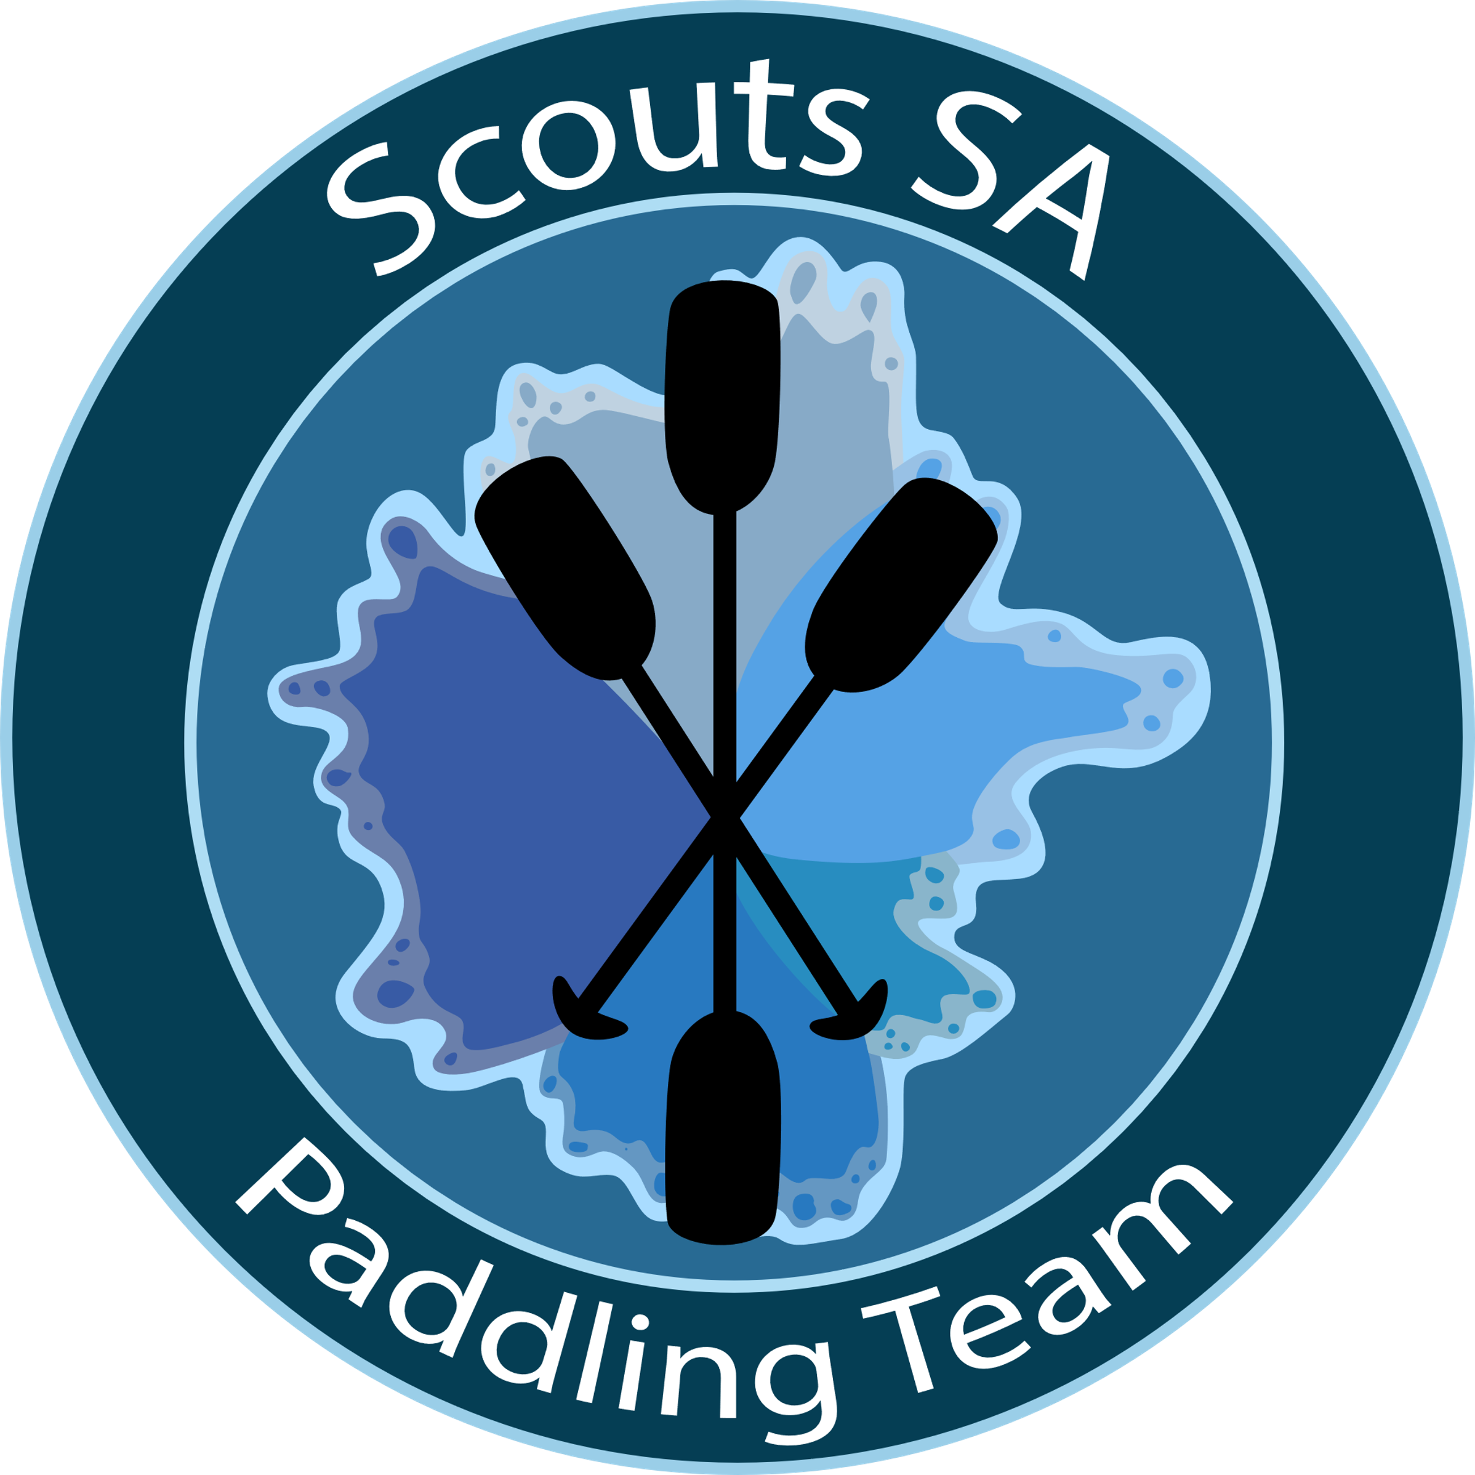  Contact –  bc.paddling@sa.scouts.com.au

Clothing
As this is a water activity it is to be expected that all participants will get wet, hence a FULL change of clothing is highly recommended.
Paddling clothing includes,
- Top with sleeves – No Cotton
- Check the weather and consider Therma tops and / wind proof jacket.
- Shorts / Leggings / Hat – sun smart compliant - remember hats generally don’t float, so we recommend a draw string on the hat
- Boating shoes - old sneakers or water shoes NOT boots/waders/thongs/crocs
Other items may include
- Sunscreen / Repellent
- Sunglasses / Glasses retaining strap
- Bag for wet clothing / Towel
- Paddling Gloves

Assistance at the beginning and end of the activity
At the end of the activity, it would be appreciated if all Youth, Parents and Leaders could assist in cleaning and packing away boats and PFD’s.
Please be mindful of social distancing measures.

There are toilets available at Tiranna reserve.

